Title of abstract for oral presentation
in 2024 spring conference of KSCSE
Author ¹, Author², and Author^{2*}
¹ Korean Society for Computational Science and Engineering, Daejeon 34141, Republic of Korea
² Korean Society for Computational Science and Engineering, Seoul 02455, Republic of Korea
Corresponding author (Electronic mail: aaa@cse.or.kr)
This template is for authors who are preparing an oral presentation in spring conference of Korean Society for Computational Science and Engineering. The length of abstract should be no more than one page, including Title, Author information, Abstract, Figure (in preference), Acknowledgement (if required), and References.
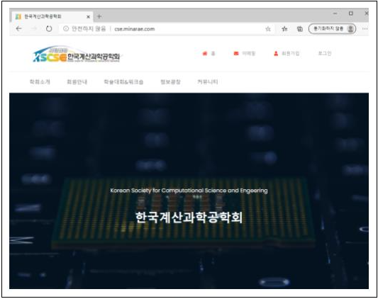
Figure 1 KCSCS website
Acknowledgments This work has been carried under the support of Korean Society for Computational Science and Engineering and Korea Institute of Science and Technology Information (KISTI).
References
[1] J. H. Kang et al., “Reference,” journal, 3, 3 (2020).

