Title of abstract for poster presentation in autumn conference of KSCSE

Author ¹, Author², and Auther^{3*}
¹ Korea Institute of Science and Technology Information, Daejeon 34141, Republic of Korea
² Korea Institute of Science and Technology Information, Daejeon 34141, Republic of Korea Corresponding author (Electronic mail: aaa@kisti.re.kr)

This template is for authors who are preparing a poster presentation in autumn conference of Korean Society for Computational Science and Engineering. The length of abstract should be no more than one page, including Title, Author information, Abstract, Figure (in preference), Acknowledgement (if required), and References.
The poster session will be held via on-line completely. All poster material including abstract will be posted on conference website. The authors should prepare presentation video whose length is within 2 minutes. The videos will be also posted on conference website on the conference date.
Figure 1 KCSCS website
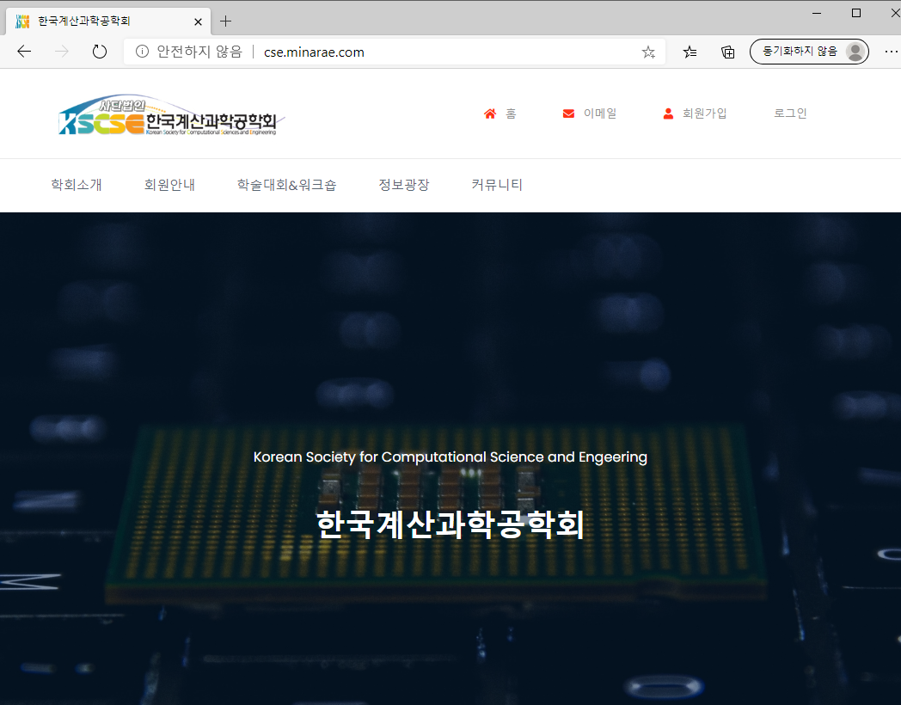

Acknowledgments This work has been carried under the support of Korean Society for Computational Science and Engineering and Korea Institute of Science and Technology Information (KISTI).

References
[1] J. H. Kang et al., “Reference,” journal, 3, 3 (2020).

